--How much Referral Fee was given on Jan 26 2019 and to whom?

create view ReferralFee as

select p.firstname||' '||p.lastname as Name ,referralcashfee as "Referral Fee"from referral r

join transactions t on (r.referralid = t.transactionid) join person p on (r.personid = p.personid)

where t.transactiondate = to_date('26-Jan-19','DD-Mon-YY');

select* from referralfee;

drop view referralfee;

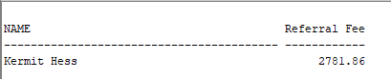

--How many clients made a perchase from John Wicke?

create view NumofClients as

select Distinct(firstname), lastname from person p

left join clienttrans ct on(p.personID = ct.clientID)

where ct.TypeID = 1

order by firstname;

SELECT * FROM NumofClients;

drop view NumofClients

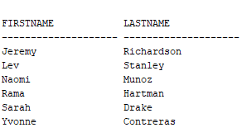

-- Show the transactions that was made starting in 2020?

CREATE VIEW TransNewYear AS

(SELECT *

FROM TRANSACTIONS

WHERE EXTRACT(YEAR FROM TO_DATE(TRANSACTIONDATE, 'DD-MON-YY')) > 2019);

SELECT * FROM TransNewYear;

drop view TransNewYear;

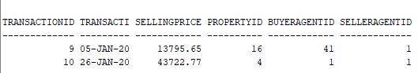

-- How many properties were sold between this year and that year?

create view NumofPropSold as

SELECT * FROM TRANSACTIONS

WHERE EXTRACT(YEAR FROM TO_DATE(TRANSACTIONDATE, 'DD-MON-YY')) BETWEEN 2018 AND 2020

ORDER BY TRANSACTIONDATE;

select * from NumofPropSold;

drop view NumofPropSold;

